GRAD 504 Team Project

— Check-In #1
Group Number # 9
Team members
1 | Cheema, Aatir | cheema11@purdue.edu
2 | Freeman, John | freem254@purdue.edu
3 | Bhadgaonkar, Shrirang Annasaheb | sbhadgao@purdue.edu
4 | Oluyomi, Temitope | toluyomi@purdue.edu

Step 1 Problem Definition

Background
Netflix and other streaming platforms invest significantly in producing a second season of a show. Thus, it is important to know what factors affect the popularity of the second season of a show. There are many factors that we discussed, such as Season 1 rating, directors, viewership, duration of shows, slope of viewership, and the time gap between two seasons. Some shows attract more viewers in later seasons because of positive audience reception, increased publicity, and growing popularity, while other shows experience lower viewership because of declining interest, longer time gaps, or changes in quality.
Being able to estimate the likely direction of season-to-season viewership could help streaming platforms, content producers, and analysts better understand audience retention.
This project focuses on predicting the direction of viewership change.

Problem Statement:
Predict whether the viewership of television shows next season will decrease relative to preceding season based on information available from television shows current and previous season.

Step 2 Data Identification and Feasibility
We will be using the datasets below to explore above problem
- Netflix’s Movie & TV Engagement Reports (2023-2026)
URL: https://www.whats-on-netflix.com/most-popular/netflix-engagement-report-search/
This data set provides global viewing engagement across four years, from 2023 to 2026, for every movie and TV title on the Netflix platform. This report contains 32,576 entries.
Each title includes:
- Runtime
- Type (Movie or TV)
- Hours viewed per reporting period
- Views per reporting period
- Total views across all years
- IMDb Non-Commercial Datasets
URL: IMDb Non-Commercial Datasets | IMDb Developer
This database is non-commercial, free, and provides daily updated detailed information about titles, ratings, episodes, crew, and people.
This database contains many tables/files available as zipped TSV files.
- title.basics.tsv.gz
Contains metadata for every title, including runtime, genre, start year, and end year.
- title.episode.tsv.gz
Contains season structure, the number of episodes per season, and season gaps.
- title.ratings.tsv.gz
This is an important table that contains season ratings and votes and can be used to calculate the direction of viewership.
- title.crew.tsv.gz
Contains season-wise directors and writers. This can be extended by calculating the popularity of directors and the popularity of shows by directors.
- title.principals.tsv.gz
Contains information about cast and crew roles.
- title.akas.tsv.gz
Contains alternate titles, languages, and regions.

The above two databases are publicly available for non-commercial use.

Data Quality Strengths
The major strengths of this dataset are:
- It directly measures global Netflix engagement.
- It includes both popular and less-popular titles.
- It covers multiple reporting periods.
- It contains quantitative variables that can be used for prediction.
- It contains aggregated title-level data and does not contain personally identifiable viewer information.

Next task and Tasks Lead
Remaining task will be divided into team members;
- Model Evaluation Strategy (Step 3)
Key Tasks
- Define metrics, success criteria, evaluation methodology
- Task Lead: Aatir Cheema
- Data Cleaning preparation
Key Tasks
- Clean and collect data by joining all the separate tables
- Make data ready to train the machine learning algorithm
- Generate charts for data evaluation, such as whicker and scatter plots
- Task lead – Shrirang Bhadgaonkar
- Model Selection –
Key Tasks
- Research compares selecting appropriate models
- Justify suitability
- Task lead – John Freeman
- Model Implementation –
Key Tasks
- Develop proposed ML model
- Perform feature engineering
- Train and generate predictions
- Task lead - Oluyomi, Temitope
- Model Evaluation and Analysis –
Key tasks
- Evaluate Model performance, analyses results , identify limitation
- Task lead – Aatir Cheema

Exploratory Data Analysis

Missing Data Analysis
While we were able to merge the two (Netflix and IMDB) dataset , some key feature for rows were missing. Here is a list of Top 10 missing features. Challenges during the data merging
- Title-name mismatch: Netflix titles did not always exactly match IMDb titles because of differences in spelling, punctuation, subtitles, and formatting.
- Season/series identification: Netflix often listed seasons separately, while IMDb structures series, seasons, and episodes using different title IDs.
- Missing or ambiguous matches: Some Netflix titles had no clear IMDb match, while others matched multiple IMDb records with similar names.
- Duplicate and inconsistent records: Multiple Netflix reporting periods, IMDb entries, and repeated title information had to be handled to avoid duplicate or incorrect merged row

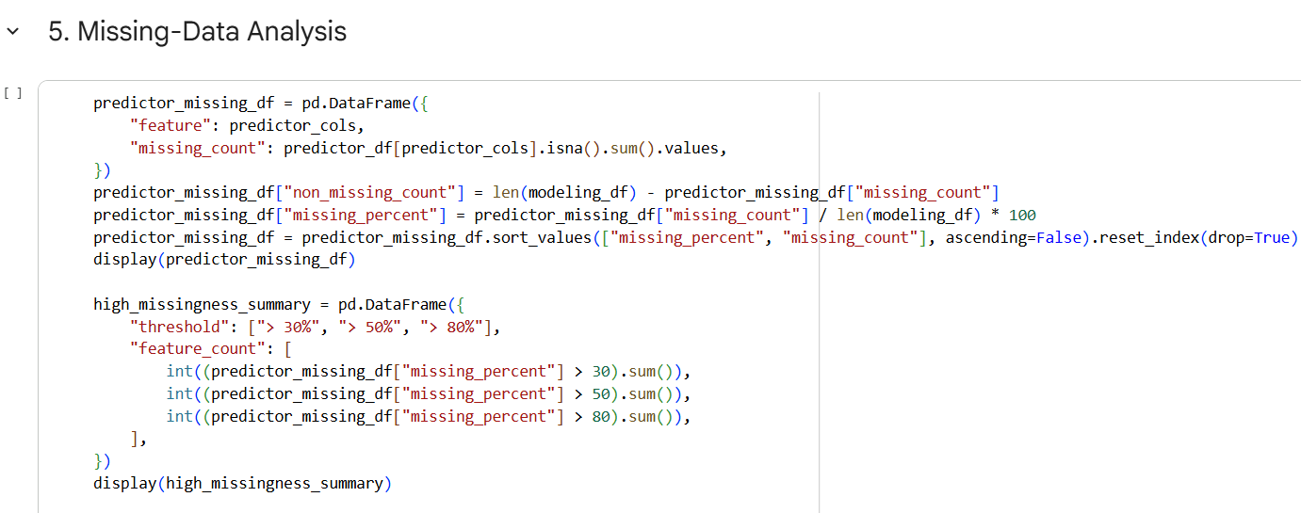
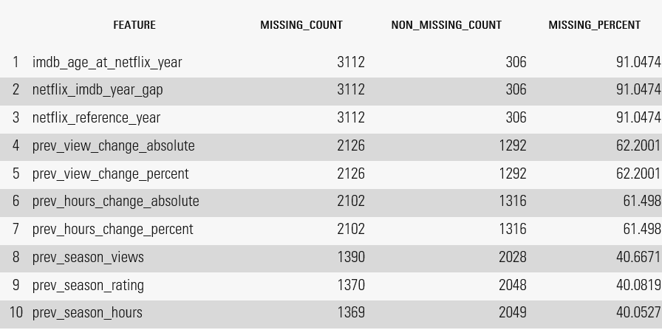

Correlation Analysis

The correlation analysis was performed to identify which numeric predictors are associated with an increase in next-season viewership. The results show that no single predictor has a strong relationship with the target, with the highest correlation being approximately 0.21 for imdb_self_count. Documentary-related features show a positive association with viewership increase, while genre_drama, runtime, and some IMDb-related features show negative associations. Overall, the relatively low correlations suggest that next-season viewership is likely influenced by a combination of multiple predictors rather than one dominant factor.

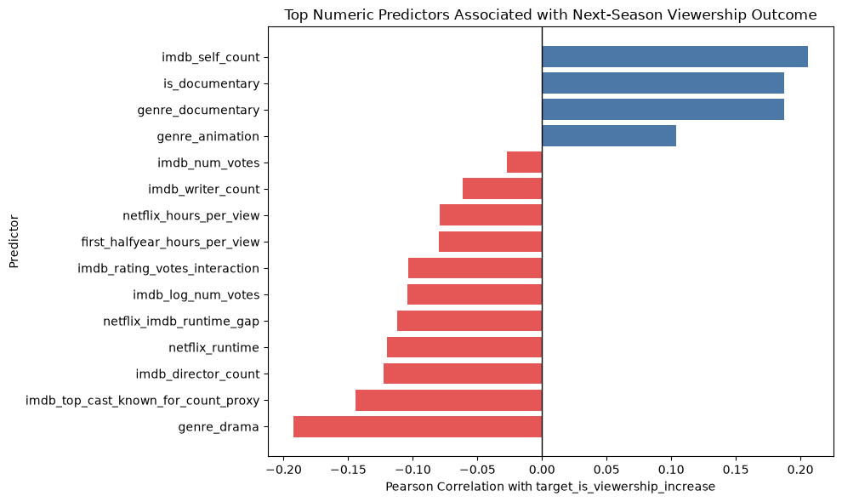

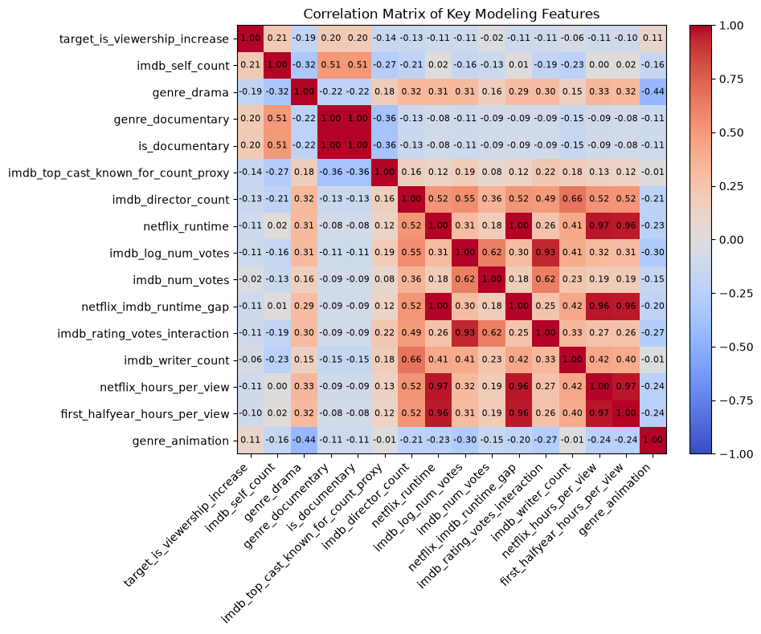

Relation between Next Season Viewership Increase Rate Vs Genre
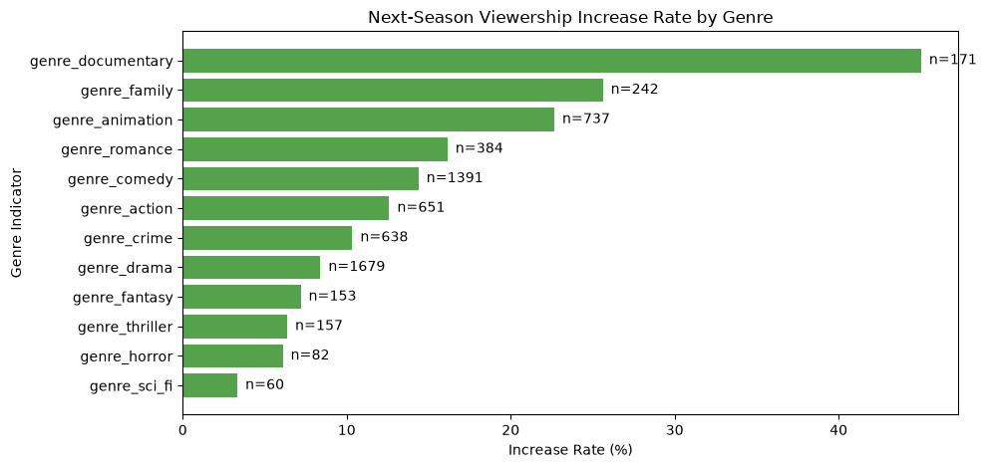
Documentary shows the highest next season viewership increase rate followed by Family and animation. While the drama has 1679 samples, it still shows relatively low increase rate. Also, as conclusion along with drama, fantasy, thriller, horror and sci-fi observes the lower increase rates.

Decision Tree
Decision Tree Classification
This model will be designed to predict if a Netflix series will retain at least 70% of its season 1 audience to its season 2 audience.
It will be divided into two categories:
- High Retention: 70% or greater (will be treated as 0)
- Low Retention: Less than 70% (will be treated as 1)
This model will use IMDb average ratings and vote count to determine which retention option is more likely.
Why Is This Method Appropriate:
This technique is appropriate because the goal is to classify the show into one of two categories. It will help identify relationships that may not be strictly linear. A decision tree can represent combinations of parameters such as IMDB ratings or runtime through a series of splits.
Tools:
This model will be implemented in Python.
- Pandas for organizing the query results
- Sickit-learn for preprocessing, training, and evaluating the model
- DecisionTreeClassifier from the sklearn.tree module
- Plot_tree to visualize the final decision rules
Training Method:
We will use Netflix and IMDB’s data set and train a model from scratch. The training portion of the dataset will be used to determine the tree’s rules. Afterwards it’ll be evaluated with an F1 score.
Computational Needs:
The dataset isn’t necessarily small, but it is all data available as CSVs. The model should be relatively easy to create and build using Python on a personal computer.
Limitations:
The primary limitation for decision trees that is of concern is overfitting if the tree becomes too large.
EVALUATION
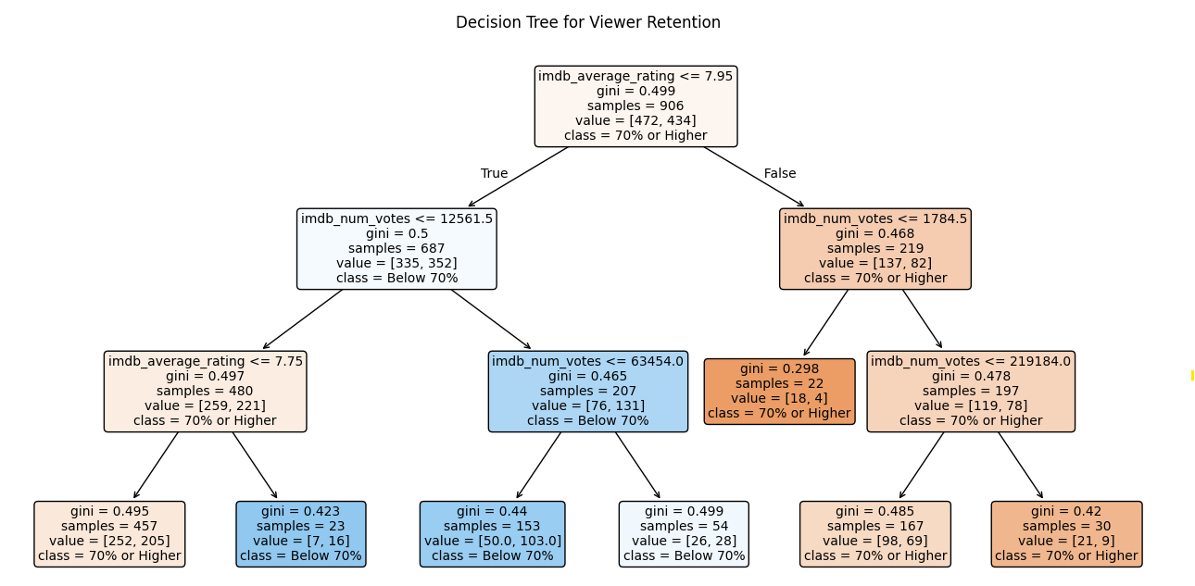
Viewer Retention Classification
The proposal is meant to evaluate how likely it is a show launched on Netflix retains 70% of their viewership. The goal is to identify shows that are likely to experience a large decrease in viewership between the first and second seasons. The same principal would be applied to a series’ season 2 and season 3 relationship.
Retention Rate = (Season 2 Total Views) / (Season 1 Total Views)
The retention rate will be the total views added up for season two divided by the total views for season one. This is not ideal but given the constraits of our data this will suffice to show off the functionality of our model.
We'll break the data up into two parts, above 70% and below 70% retention from season. The model will use IMDb average rate and vote count as predictors.
Evaluation Data:
The data will come from Netflix’s engagement report and IMDB’s dataset. 70% of the data will be used for training and 30% will be used for testing. The scope will be limited to series from 2023 to 2026 since that is the data available to via Netflix’s engagement report.
Evaluation Metrics:
F1 score will let us evaluate the model’s ability to identify both low false positives and false negatives while also measuring the model’s ability to viewer retention.
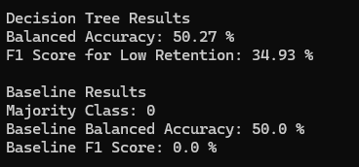
The tree was able to identify some low retention cases, but its overall performance isn't substantial enough to call the model reliable. This leads to a similar conclusion where IMDb rating and vote count aren't enough separate the groups.

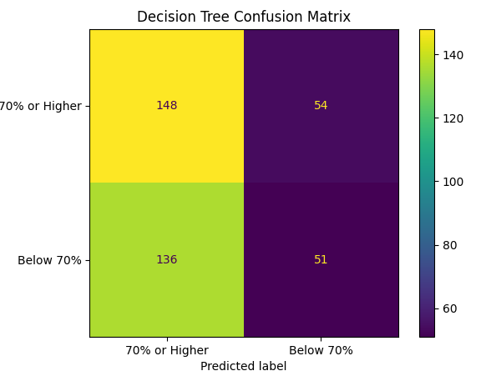
Of the 187 test set shows that actually had below 70% retention, 136 were incorrectly predicted as 70% or higher, while only 51 were correctly identified.

Multiple Linear Regression
Proposal 2: Multiple Linear Regression
This proposal will is designed to predict the exact percentage of viewers retained from season 1 to season 2 of a series.
Why Is This Method Appropriate:
The outcome being predicted this time is numerical as opposed to a binary categorization with the decision tree method. It can use a variety of factors such as:
- IMDB rating
- Viewership counts
- Number of months or years between seasons
- Cast changes
- Change in episode count
- Genre
- Total runtime
Tools:
This model will be implemented in Python.
- Pandas for organizing the query results
- Sickit-learn for preprocessing, training, and evaluating the model
- LinearRegression from the sklearn.linear_model module
- Simple Imputer for missing values
- OneHotEncoder for categorical variables
Training Method:
There are no plans to use a foundational model to build off of. We will use Netflix and IMDB’s data set and train a model from scratch. The model will be evaluated using the continuous evaluation plan from Step 3 (MAE, RMSE, and baseline comparisons).
Computational Needs:
The dataset isn’t necessarily small, but it is all data available as CSVs. The model should be relatively easy to create and build using Python on a personal computer.
Limitations:
This model may not be able to capture more complex relationships. Linear regression also doesn’t limit predictions to a certain range, so the percent ranges may end up varying a lot.
EVALUATION
Proposal 2: Continuous Viewer Retention Prediction
As opposed to predicting a category, this model will aim to predict the exact retention percentage. We would apply a similar retention rate formula to this as we did in proposal one. In contrast to the previous approach where it distributes the series into one of two categories, greater or less than 70%, we want to get a closer actual percent. We’ll use similar factors like IDMB ratings, gap between season releases, genre, episode count, cast changes, etc.
Evaluation Data:
The evaluation data will be identical to the previous proposal where the data will come from Netflix’s engagement report and IMDB’s dataset. 80% of the data will be used for training and 20% will be used for testing. The range willl again be limited to data available from 2023 to 2026.
Evaluation Metrics:
Mean Absolute Error (MAE) and Root Mean Squared Error (RMSE) will be used to measure the average difference between the predicted retention and the actual retention percentage. RMSE will place a larger penalty on inaccurate predictions.
A baseline value will also be established using the median retention percentage of the series in the testing data set. We would then establish a baseline MAE and RMSE.
Evaluation Method:
Similarly the predictions will be compared with the actual viewer retention rates. MAE and RMSE will be calculated across the testing set to find the error. The model that produces the lowest error while performing consistently is going to be the final model.
Success Criteria:
- The goal is to produce a lower MAE than 15% when determining the retention rate between season 1 and season 2.
- Avoiding large prediction errors
- Consistent results
Producing a lower MAE and RMSE than the baseline model

conclusion
Companies spend millions of dollars investing in television programs. Tons of resources are allocated into releasing what should be a successful show. The goal is to ultimately find a trend in why shows, primarily on Netflix, succeed or fail when releasing a second season.

AI Usage:
- AI has been used to research the movies database.
- Help and brainstorming in defining a clear problem statement
- Researching Data for the project
https://chatgpt.com/share/6a5d32db-2c28-83ea-a4e3-f39d1ee32e6d

